Indexes

Sequences

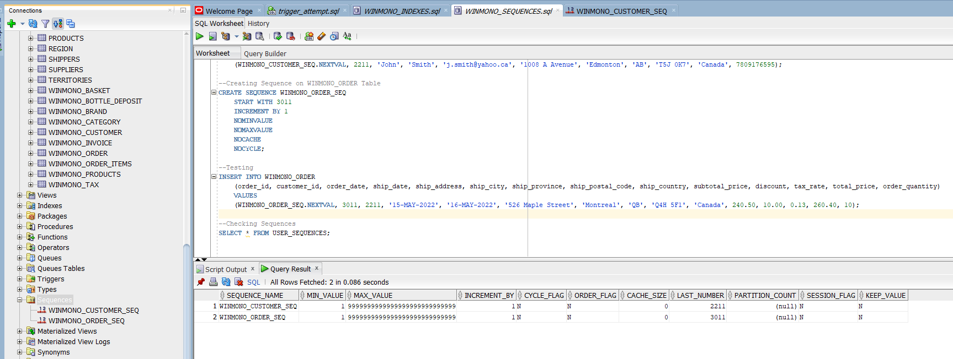

Procedures

Functions

Triggers

